**MIDDLETON CHENEY FOOTBALL CLUB**

**ANNUAL GENERAL MEETING**

**1972**

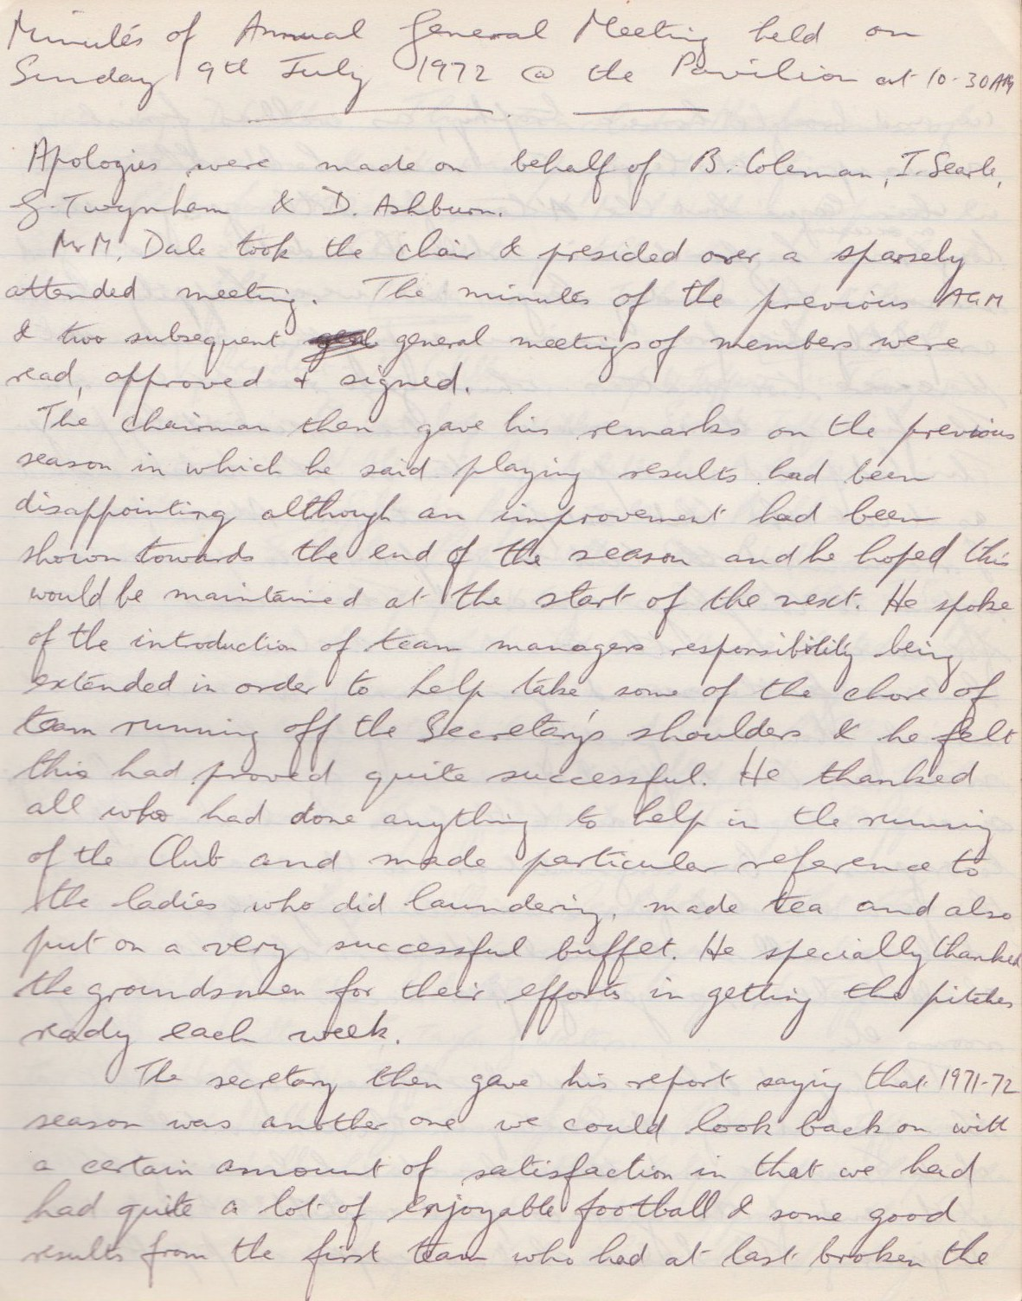

**Continue**

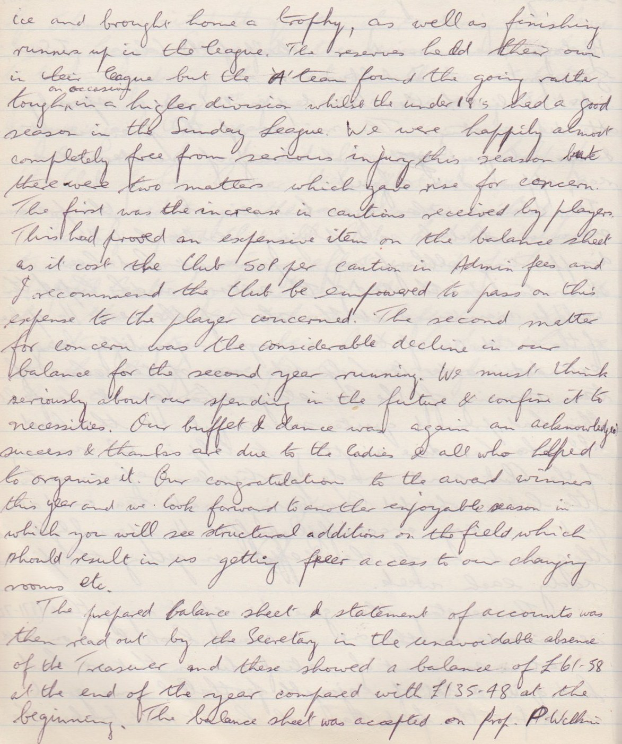

**Continued**

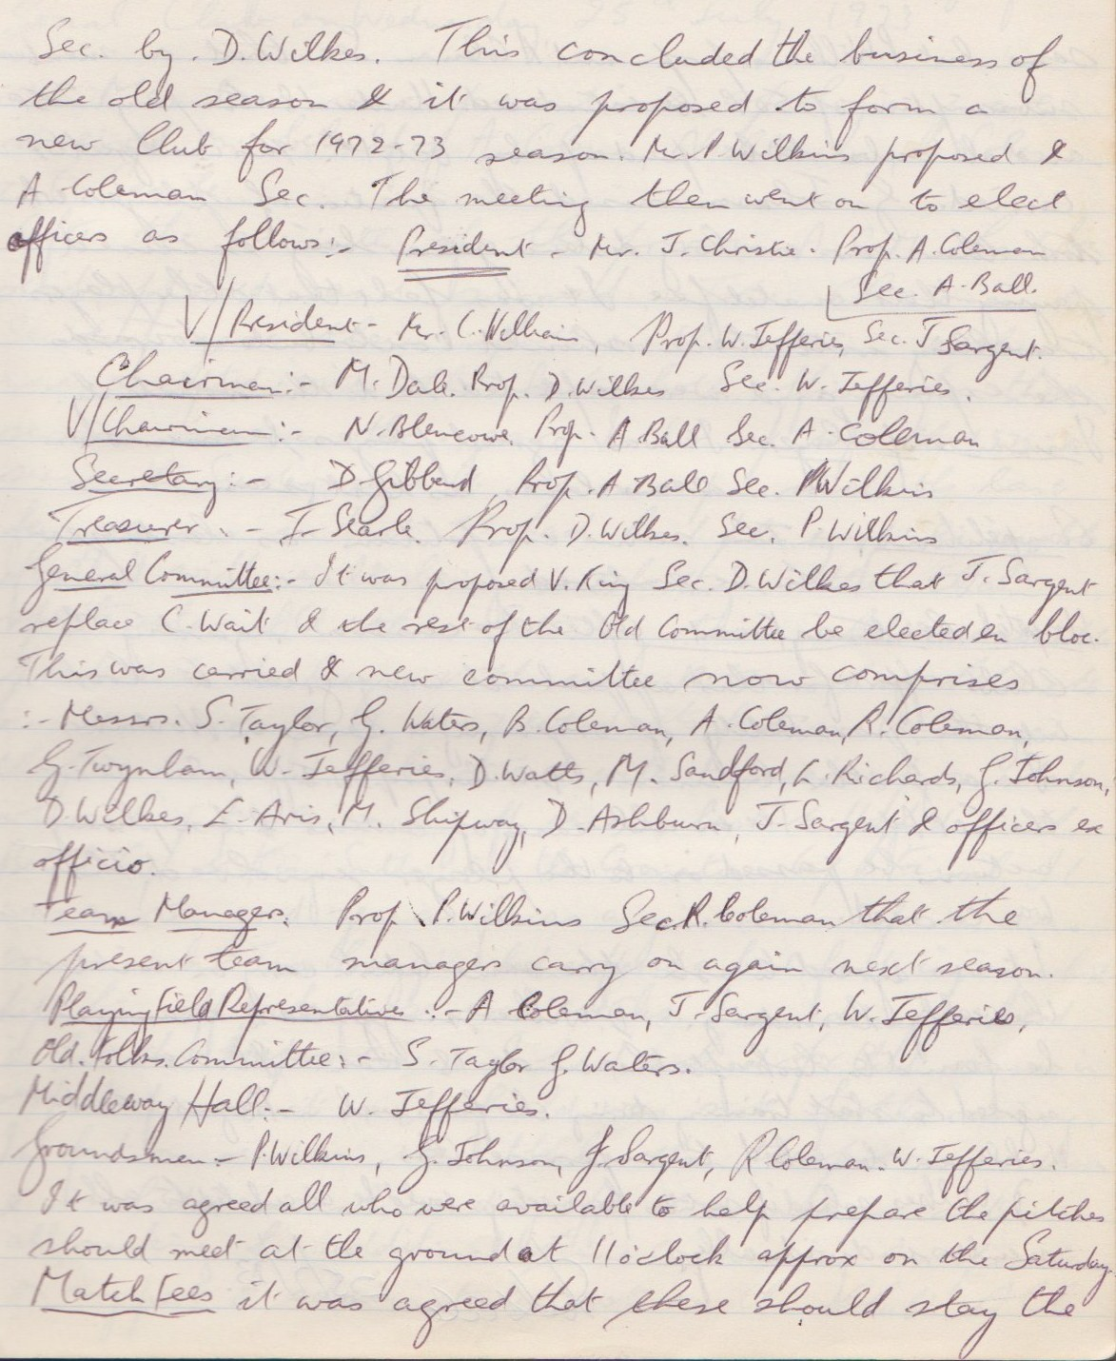

**Continued**

